**Testing Document for Quizzard**

TEST #1

In order to ensure that our program works and works correct, we will use different inputs to see different outcomes and test to see whether out program is able to run it. Our program is a trivia game that will ask you 10 questions and you will answer them. The questions get harder as you go and you can earn up to $3000.

***Input:***

* Input users name
* Input question answers

***Expected output:***

We expect the program to output:

* The answer of the user
* Output whether it is correct or incorrect

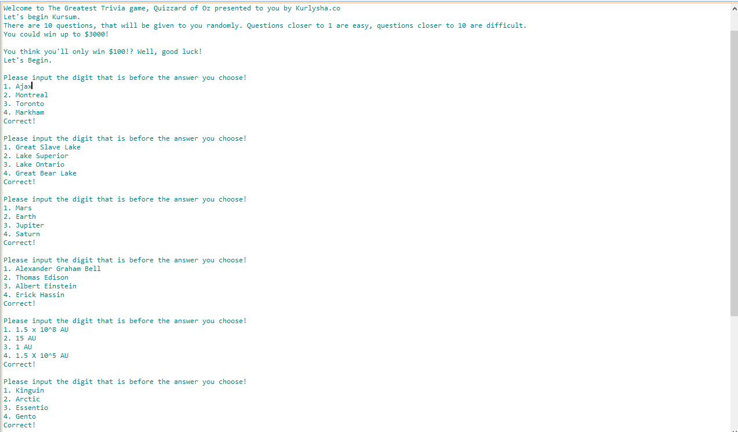***Actual output:***

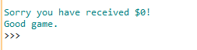

***Results:***

The program ran correctly and passed as the program outputted the correct answers and as I got a question correct, the program presented another question. This is how I know my program passed.

TEST #2

***Input:***

* Users name
* Users answers
* An invalid answer

***Expected Output:***

I expect the program to output:

* An invalid answer

***Actual Output:***

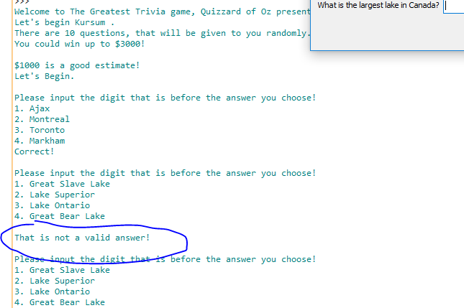

***Results:***

The program was a success and passes once again, as our expected output was the same as the actual output which tells us that we have not entered a valid input if we input a letter or un-optional number. Thus, telling us our program passes.